WEEK 6 : COGNIZANT DN 4.0 FSE HANDS-ON EXERCISES

(MANDATORY PLUS ADDITIONAL)

* **ReactJS-HOL**

**Exercise 1: Create a new React Application with the name “myfirstreact”, Run the application to print “welcome to the first session of React” as heading of that page.**

**Solution:**

**App.js**

import React from 'react';

function App() {

  return (

    <div>

      <h1>Welcome to the first session of React</h1>

    </div>

  );

}

export default App;

**Output:**

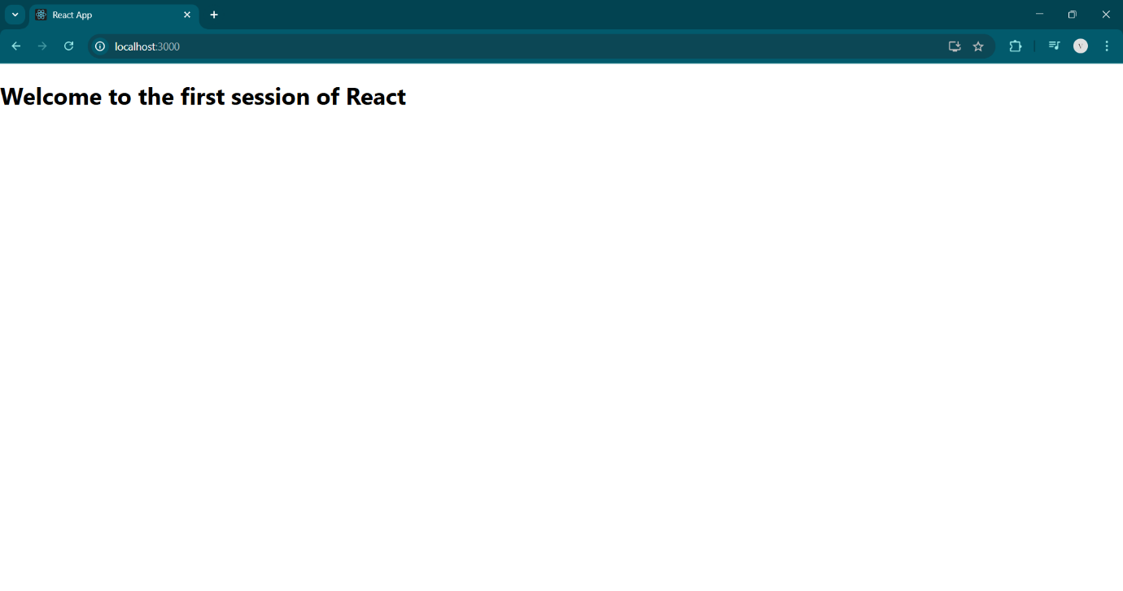

**Exercise 2: Create a react app for Student Management Portal named scorecalculatorapp and create a function component named “CalculateScore” which will accept Name, School, Total and goal in order to calculate the average score of a student and display the same.**

**Solution:**

**Home.js**

import React from 'react';

class Home extends React.Component {

  render() {

    return (

      <div>

        <h2>Welcome to the Home page of Student Management Portal</h2>

      </div>

    );

  }

}

export default Home;

**About.js**

import React from 'react';

class About extends React.Component {

  render() {

    return (

      <div>

        <h2>Welcome to the About page of the Student Management Portal</h2>

      </div>

    );

  }

}

export default About;

**Contact.js**

import React from 'react';

class Contact extends React.Component {

  render() {

    return (

      <div>

        <h2>Welcome to the Contact page of the Student Management Portal</h2>

      </div>

    );

  }

}

export default Contact;

**App.js**

import React from 'react';

import './App.css';

import Home from './Components/Home';

import About from './Components/About';

import Contact from './Components/Contact';

function App() {

  return (

    <div className="App">

      <h1>Student Management Portal</h1>

      <Home />

      <About />

      <Contact />

    </div>

  );

}

export default App;

**Output:**

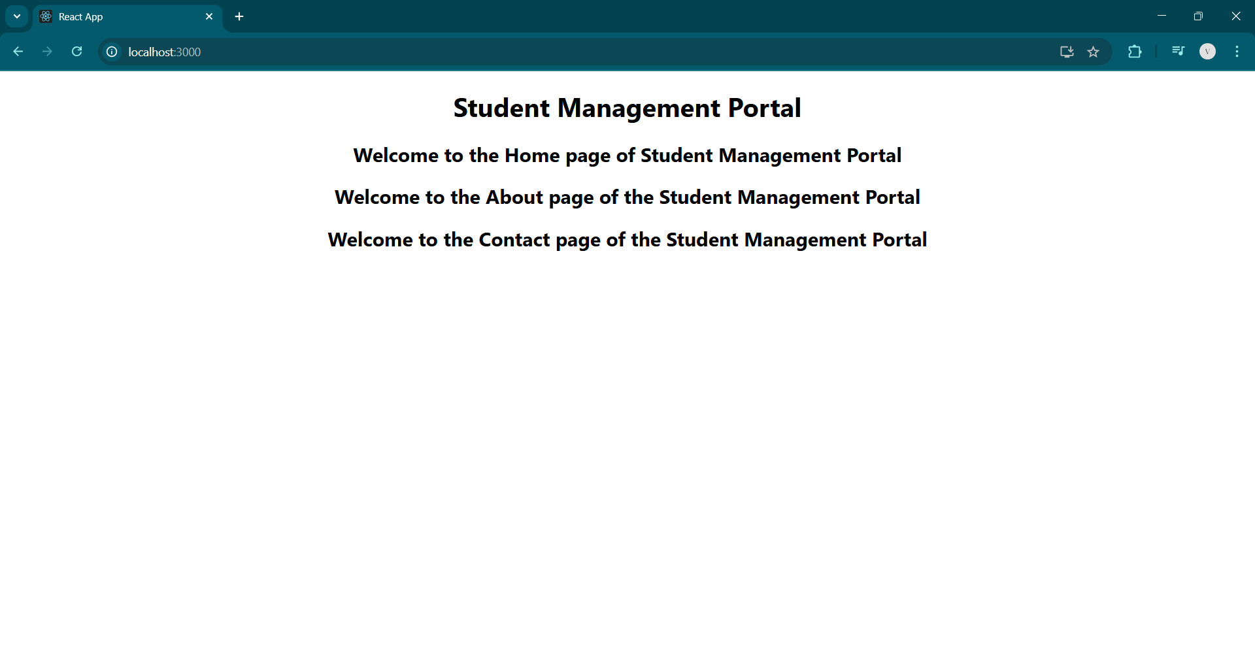

**Exercise 3: Create a react app for Student Management Portal named scorecalculatorapp and create a function component named “CalculateScore” which will accept Name, School, Total and goal in order to calculate the average score of a student and display the same.**

**Solution:**

**CalculateScore.js**

// src/Components/CalculateScore.js

import React from 'react';

import '../Stylesheets/mystyle.css';

function CalculateScore(props) {

  const { name, school, total, goal } = props;

  const average = (total / goal).toFixed(2);

  return (

    <div className="score-card">

      <h2>Student Score Details</h2>

      <p><strong>Name:</strong> {name}</p>

      <p><strong>School:</strong> {school}</p>

      <p><strong>Total Marks:</strong> {total}</p>

      <p><strong>Goal:</strong> {goal}</p>

      <p><strong>Average Score:</strong> {average}</p>

    </div>

  );

}

export default CalculateScore;

**mystyle.css**

/* src/Stylesheets/mystyle.css */

.score-card {

  border: 2px solid #4CAF50;

  padding: 20px;

  margin: 30px auto;

  width: 400px;

  background-color: #f9f9f9;

  box-shadow: 2px 2px 12px rgba(0,0,0,0.1);

  font-family: Arial, sans-serif;

}

.score-card h2 {

  color: #4CAF50;

  text-align: center;

}

.score-card p {

  font-size: 16px;

  margin: 8px 0;

}

**App.js**

// src/App.js

import React from 'react';

import './App.css';

import CalculateScore from './Components/CalculateScore';

function App() {

  return (

    <div className="App">

      <CalculateScore

        name="Ananya"

        school="Sunrise Public School"

        total={450}

        goal={5}

      />

    </div>

  );

}

export default App;

**Output:**

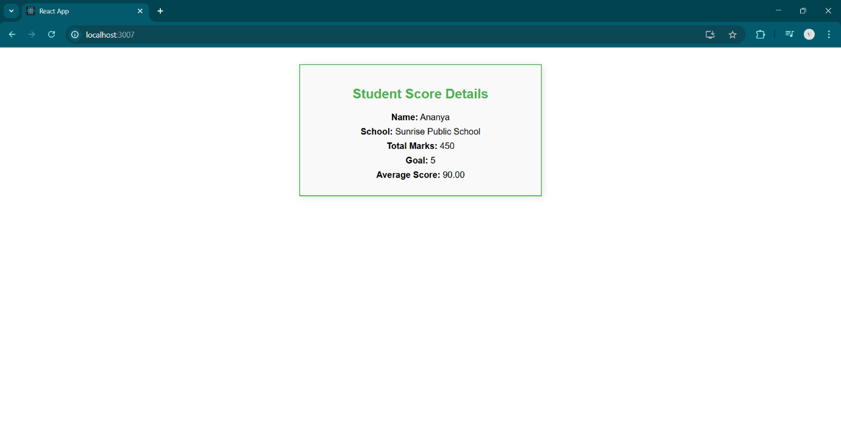

**Exercise 4: Create a new react application using *create-react-app* tool with the name as “blogapp”**

**Solution:**

**Post.js**

import React from 'react';

class Post extends React.Component {

  render() {

    const { title, body } = this.props;

    return (

      <div style={{ borderBottom: '1px solid #ccc', marginBottom: '16px' }}>

        <h3>{title}</h3>

        <p>{body}</p>

      </div>

    );

  }

}

export default Post;

**Posts.js**

import React from 'react';

import Post from './Post';

class Posts extends React.Component {

  constructor(props) {

    super(props);

    this.state = {

      posts: [],

    };

  }

  loadPosts = () => {

    fetch('https://jsonplaceholder.typicode.com/posts')

      .then(res => res.json())

      .then(data => this.setState({ posts: data }))

      .catch(err => console.error("Failed to fetch posts", err));

  };

  componentDidMount() {

    this.loadPosts();

  }

  render() {

    const { posts } = this.state;

    return (

      <div>

        <h1>Blog Posts</h1>

        {posts.map(post => (

          <Post key={post.id} title={post.title} body={post.body} />

        ))}

      </div>

    );

  }

}

export default Posts;

**App.js**

import React from 'react';

import './App.css';

import Posts from './Posts';

function App() {

  return (

    <div className="App">

      <Posts />

    </div>

  );

}

export default App;

**Output:**

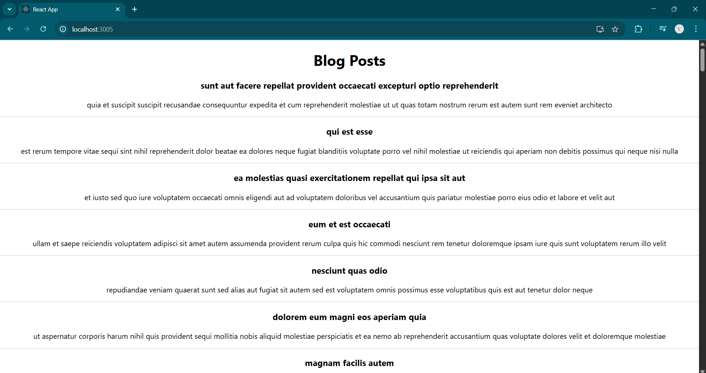

**Exercise 5: My Academy team at Cognizant want to create a dashboard containing the details of ongoing and completed cohorts. A react application is created which displays the detail of the cohorts using react component. You are assigned the task of styling these react components.**

**Solution:**

**CohortDetails.js**

import React from 'react';

import styles from '../Stylesheets/CohortDetails.module.css';

function CohortDetails(props) {

  const { name, status, duration, participants } = props;

  const headingStyle = {

    color: status === 'ongoing' ? 'green' : 'blue',

  };

  return (

    <div className={styles.box}>

      <h3 style={headingStyle}>{name}</h3>

      <dl>

        <dt>Status:</dt>

        <dd>{status}</dd>

        <dt>Duration:</dt>

        <dd>{duration}</dd>

        <dt>Participants:</dt>

        <dd>{participants}</dd>

      </dl>

    </div>

  );

}

export default CohortDetails;

**CohortDetails.module.css**

.box {

  width: 300px;

  display: inline-block;

  margin: 10px;

  padding: 10px 20px;

  border: 1px solid black;

  border-radius: 10px;

  background-color: #f5f5f5;

}

dt {

  font-weight: 500;

}

**App.js**

import React from 'react';

import './App.css';

import CohortDetails from './Components/CohortDetails';

function App() {

  return (

    <div className="App">

      <h1>My Academy Cohort Dashboard</h1>

      <CohortDetails

        name="React Bootcamp"

        status="ongoing"

        duration="6 weeks"

        participants={40}

      />

      <CohortDetails

        name="Angular Fast Track"

        status="completed"

        duration="4 weeks"

        participants={25}

      />

    </div>

  );

}

export default App;

**Output:**

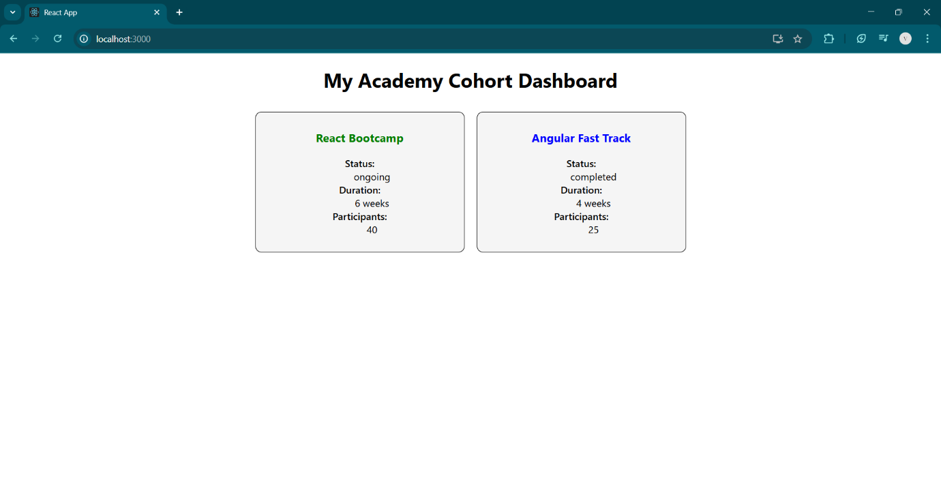

**Exercise 6: Cognizant Academy teams want to maintain a list of trainers along with their expertise in a SPA using React as the technology. You are assigned the task of creating this React app.**

**The following trainers’ data application will deal.**

1. **T-ID**
2. **Name**
3. **Phone**
4. **Email**
5. **Stream**
6. **Skills**

**Solution:**

**Trainer.js**

class Trainer {

  constructor(trainerId, name, email, phone, technology, skills) {

    this.trainerId = trainerId;

    this.name = name;

    this.email = email;

    this.phone = phone;

    this.technology = technology;

    this.skills = skills;

  }

}

export default Trainer;

**TrainersMock.js**

const trainers = [

  {

    trainerId: "T001",

    name: "Anjali Sharma",

    email: "anjali.sharma@example.com",

    phone: "9876543210",

    technology: "React",

    skills: "JS, React, Redux"

  },

  {

    trainerId: "T002",

    name: "Ravi Kumar",

    email: "ravi.kumar@example.com",

    phone: "9123456780",

    technology: "Angular",

    skills: "TS, Angular, RxJS"

  },

  {

    trainerId: "T003",

    name: "Priya Mehta",

    email: "priya.mehta@example.com",

    phone: "9988776655",

    technology: "Vue",

    skills: "Vue, JS, Vuex"

  }

];

export default trainers;

**Home.js**

import React from 'react';

function Home() {

  return (

    <div>

      <h2>Welcome to the Trainers Portal</h2>

      <p>Select a section using the navigation above.</p>

    </div>

  );

}

export default Home;

**TrainersList.js**

import React from 'react';

import { Link } from 'react-router-dom';

import trainers from '../TrainersMock';

function TrainersList() {

  return (

    <div>

      <h2>Trainers List</h2>

      <ul>

        {trainers.map(trainer => (

          <li key={trainer.trainerId}>

            <Link to={`/trainer/${trainer.trainerId}`}>{trainer.name}</Link>

          </li>

        ))}

      </ul>

    </div>

  );

}

export default TrainersList;

**TrainerDetails.js**

import React from 'react';

import { useParams } from 'react-router-dom';

import trainers from '../TrainersMock';

function TrainerDetails() {

  const { id } = useParams();

  const trainer = trainers.find(t => t.trainerId === id);

  if (!trainer) {

    return <p>Trainer not found.</p>;

  }

  return (

    <div>

      <h2>Trainer Details</h2>

      <p><strong>ID:</strong> {trainer.trainerId}</p>

      <p><strong>Name:</strong> {trainer.name}</p>

      <p><strong>Email:</strong> {trainer.email}</p>

      <p><strong>Phone:</strong> {trainer.phone}</p>

      <p><strong>Technology:</strong> {trainer.technology}</p>

      <p><strong>Skills:</strong> {trainer.skills}</p>

    </div>

  );

}

export default TrainerDetails;

**App.js**

import React from 'react';

import './App.css';

import { BrowserRouter as Router, Routes, Route, Link } from 'react-router-dom';

import Home from './Components/Home';

import TrainersList from './Components/TrainersList';

import TrainerDetails from './Components/TrainerDetails';

function App() {

  return (

    <Router>

      <div>

        <h1>Trainers Application</h1>

        <nav>

          <ul>

            <li><Link to="/">Home</Link></li>

            <li><Link to="/trainers">Trainers</Link></li>

          </ul>

        </nav>

        <Routes>

          <Route path="/" element={<Home />} />

          <Route path="/trainers" element={<TrainersList />} />

          <Route path="/trainer/:id" element={<TrainerDetails />} />

        </Routes>

      </div>

    </Router>

  );

}

export default App;

**Output:**

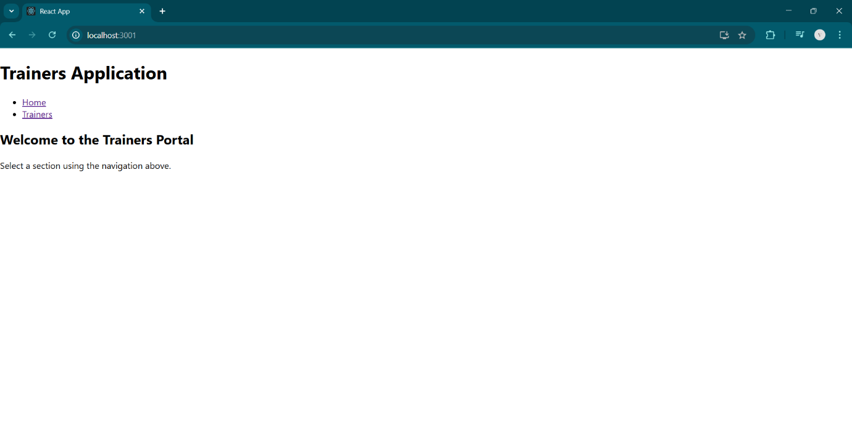

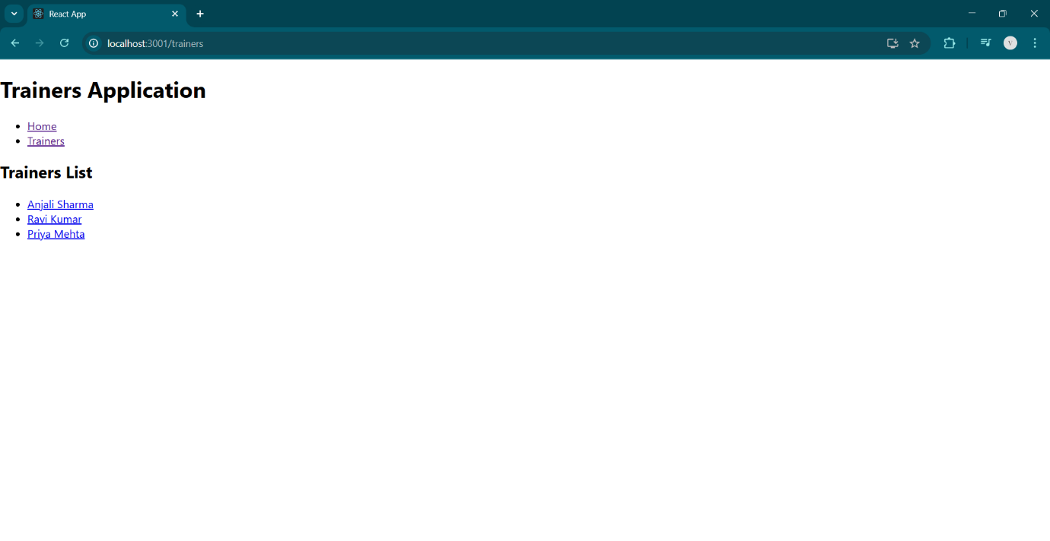

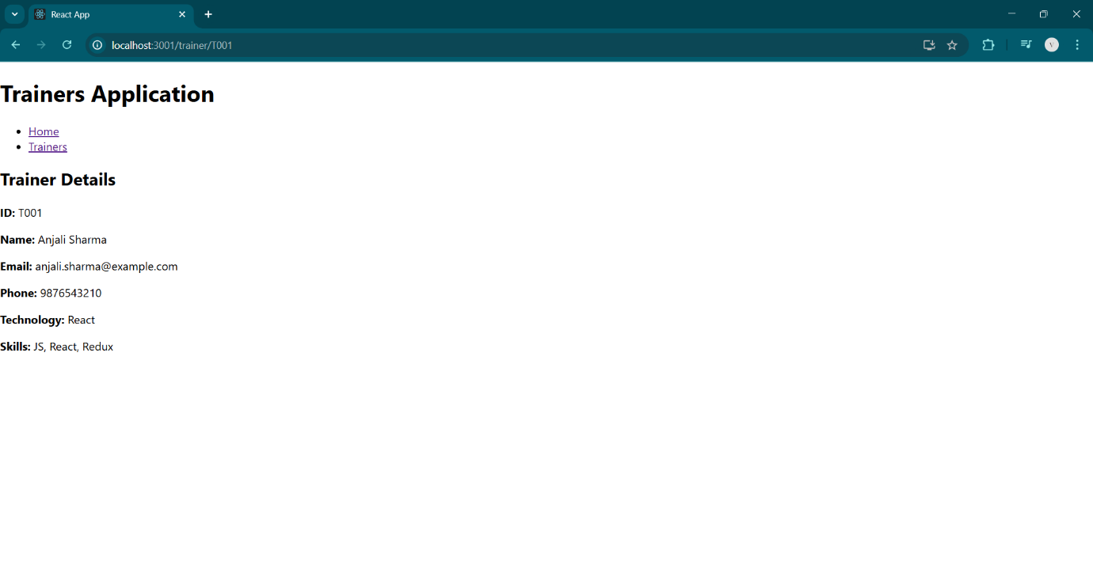

**Exercise 7: Create a React Application named “shoppingapp” with a class component named “OnlineShopping” and “Cart”.**

**Solution:**

**Cart.js**

import React from 'react';

class Cart extends React.Component {

  render() {

    const { itemname, price } = this.props;

    return (

      <div>

        <p>Item: {itemname} – Price: ₹{price}</p>

      </div>

    );

  }

}

export default Cart;

**OnlineShopping.js**

import React from 'react';

import Cart from './Cart';

class OnlineShopping extends React.Component {

  render() {

    const items = [

      { itemname: 'Shoes', price: 1500 },

      { itemname: 'T-shirt', price: 800 },

      { itemname: 'Jeans', price: 1800 },

      { itemname: 'Watch', price: 2500 },

      { itemname: 'Cap', price: 300 }

    ];

    return (

      <div>

        <h2>Shopping Cart</h2>

        {items.map((item, index) => (

          <Cart key={index} itemname={item.itemname} price={item.price} />

        ))}

      </div>

    );

  }

}

export default OnlineShopping;

**App.js**

import React from 'react';

import './App.css';

import OnlineShopping from './OnlineShopping';

function App() {

  return (

    <div className="App">

      <OnlineShopping />

    </div>

  );

}

export default App;

**Output:**

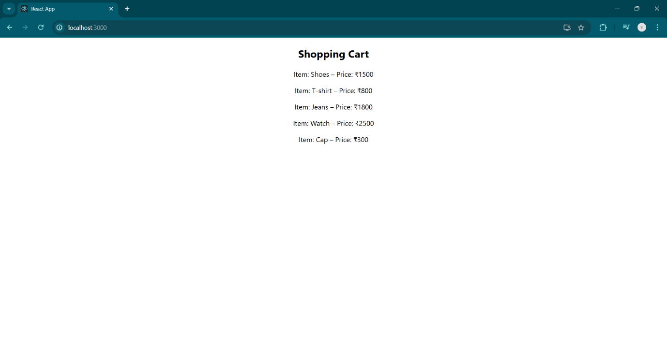

**Exercise 8: Create a React App “counterapp” which will have a component named “CountPeople” which will have 2 methods.**

**UpdateEntry() 🡪 which will display the number of people who entered the mall.**

**UpdateExit() 🡪 which will display the number of people who exited the mall.**

**Solution:**

**CountPeople.js**

import React from 'react';

class CountPeople extends React.Component {

  constructor(props) {

    super(props);

    this.state = {

      entryCount: 0,

      exitCount: 0

    };

  }

  updateEntry = () => {

    this.setState(prevState => ({

      entryCount: prevState.entryCount + 1

    }));

  };

  updateExit = () => {

    this.setState(prevState => ({

      exitCount: prevState.exitCount + 1

    }));

  };

  render() {

    return (

      <div>

        <h2>Mall Entry Management</h2>

        <p>People Entered: {this.state.entryCount}</p>

        <p>People Exited: {this.state.exitCount}</p>

        <button onClick={this.updateEntry}>Login</button>

        <button onClick={this.updateExit}>Exit</button>

      </div>

    );

  }

}

export default CountPeople;

**App.js**

import React from 'react';

import './App.css';

import CountPeople from './CountPeople';

function App() {

  return (

    <div className="App">

      <CountPeople />

    </div>

  );

}

export default App;

**Output:**

